Ortiz Guzman, Julio

1 November, 2021

ECe 3200-01 Lab 10

High Frequency Performance of CASCODE Amplifier

**Objective:**

The objective of this lab is to measure the small-signal frequency response of a CASCODE amplifier and compare the bandwidth improvement versus the preceding CE amplifier. Student will also apply design techniques to meet specifications and will analyze the small signal performance by employing a hybrid-π transistor model. A PSpice simulation is required to back up the analysis.

**Prelab:**

1. Design the CASCODE amplifier shown in fig.1 so that IC1q ≈ IC2 q = 10 mA and the output ac resistance, Ro, is 470 Ω. Take IR1 =11 IB2q , IR2 = 10IB1q and IR3 = 9IB1q in order to achieve a good DC stability. Also take VE = 2.7 V and VB2 = 8.0 V so that the terminal voltage of both transistors will be identical to the transistor used in the previous experiment. This measure will ensure the junction capacitances in both circuits will remain unchanged. For both transistors assume an identical current gain of, β ≈ 100 and VT = 25 mV, where VT is the thermal voltage of the semiconductor.
2. Draw the small signal equivalent circuit of the CASCODE stage using hybrid-π models. Determine the mid-band frequency voltage gain of the CE stage defined as Av1 = vo1 / vi. Also calculate the gain of the CB stage, Av2 = vo / vi2. Determine the input impedance, Rin1 = vi / iin, of the CE amplifier. Also determine the input impedance Rin2 of the CB stage. It will help if the CB stage is presented as an amplifier with an input impedance of Rin2 ≈ 1/ gm and a dependent output current source of gm vi2.
3. Determine the input and output capacitances of the amplifiers using the Miller effect partitioning technique. For both transistors the collector-to-base junction capacitance, Cμ (AKA Ccb) may be assumed to be approximately 8 pF and the base-to-emitter capacitance, Cπ ( AKA Cbe ) may be determined from the equation, Cπ = gm / 2π fT - Cμ, where gm = ICq/ VT .Here fT is the unity current- gain frequency of the 2N2222A transistor (See ref., CH 17.4). For 2N2222A fT may be assumed to be 300 MHz (search Web for Datasheets).

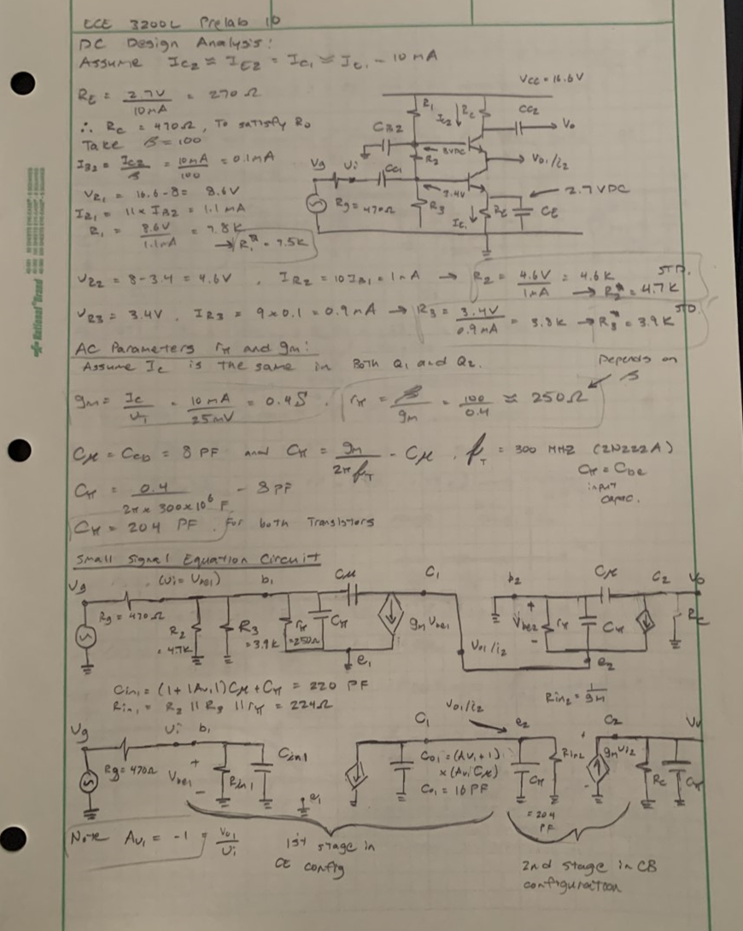

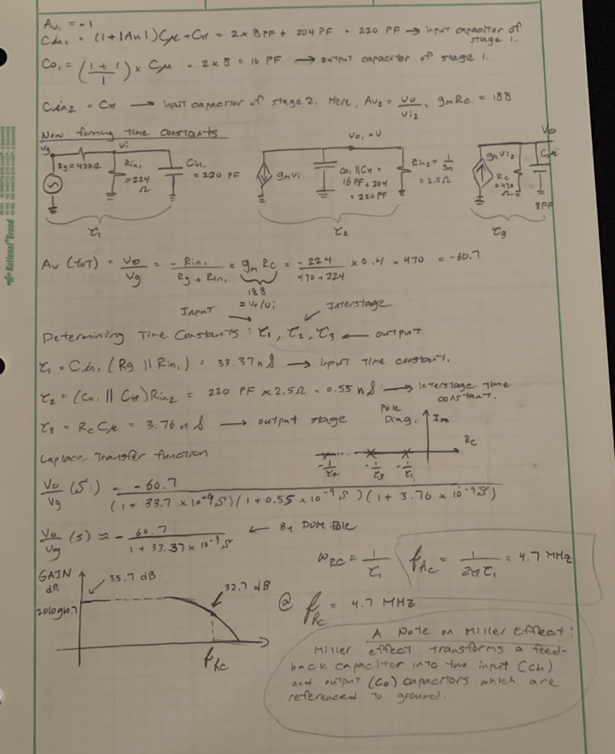

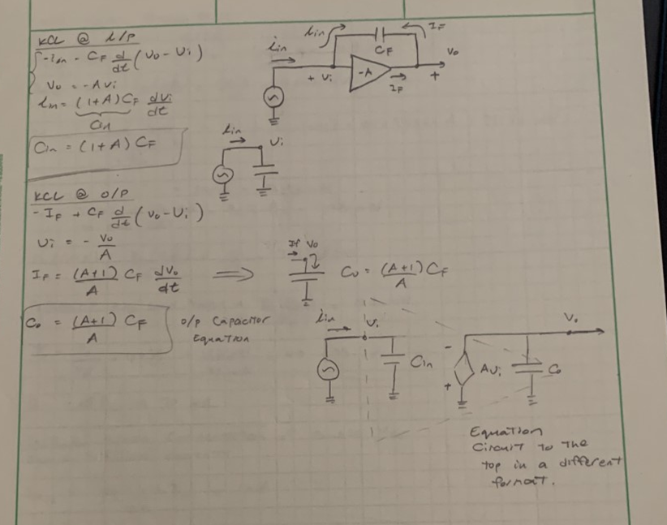

**Procedure:**

1. Construct the circuit as shown in fig. 1 and make the following DC measurements

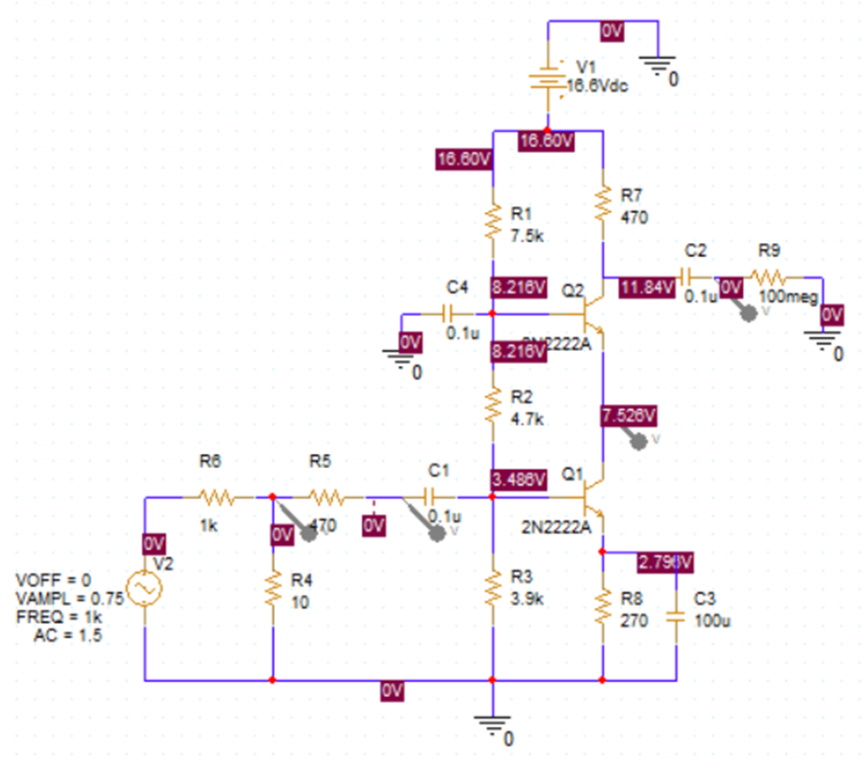

VE1 = 2.796V, VB1 = 3.486V, VC2 = 11.48V, VB2 = 8.216V

IC2 = (VCC – VC2 )/ RC = 10.9 mA (calculate from above)

1. Set vg = 15 mVpp by adjusting the signal generator amplitude to about 1.5 Vpp; the 1000/10 resistive attenuator will reduce the generator output by approximately 100 times so that the desired 15 mVpp signal can be obtained.
2. Measure the mid-band frequency (at 5 –10 kHz range) voltage gain, Av, Ag , Av1, Av2, the input resistance Rin­ and the output resistance Ro:

Av = vo / vi = -54.1 , Av1 = vo1 / vi = 0.999, Av2 = vo / vi2 = 122.32,

Ag = vo / vg = 53.9 , Rin1 = vi / iin = 224 Ω, Ro = 470 Ω

where iin may be determined from , iin = (vg – vi )/ Rg.

1. Now apply the vg = 15 mVpp input signal and vary the frequency from 10 kHz to 10 MHz and **graph** the **“stage” overall** voltage gain , defined as **Ag = vo /vg** , versus the applied frequency. Construct a table of Ag versus the frequency and specifically measure the –3 dB higher cutoff frequency point , fch,

fch = 4.8 MHz

Fig.1

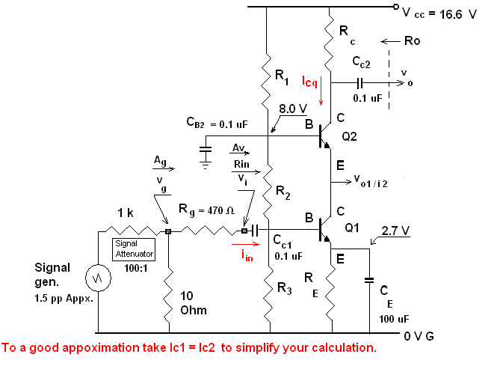

**Conclusion:**

As a result of this lab, I was able to better understand how to make measurements based off the small-signal frequency response of a CASCODE amplifier and compare the bandwidth improvement versus the preceding CE amplifier examined in former labs. Although I was not able perform the lab physically, I was still able to visualize and understand the circuit with the help of pSpice, and the zoom meeting provided. As mentioned in the lab manual, the CASCODE amplifier is comprised of two cascade stages of a CE and CB amplifier. The CE makes up the input stage with a very low voltage gain of Av1 ≈ -1 and the second (the output) is a wideband CB amplifier with a voltage gain of Av2 = gm RC. The input impedance of CB, Rin2, viewed at the emitter, is very low equal to, Rin2 ≈ 1 / gm. It is this low input impedance that causes the CE to have a low voltage gain. The common CE amplifier has a much larger input capacitance due to the enhanced Miller effect. Since the voltage gain of CE is reduced, the input capacitance will be reduced significantly, and increasing the overall bandwidth. I thought this lab was relatively easy to follow and it improved my knowledge on CASCODE amplifiers.